CloudOPs

**Resources**

LDAP - Lightweight Directory Access Protocol

EPDSM – TRACKING

EAI –

OVO – Monitoring

**Location**

|  |  |  |
| --- | --- | --- |
| EDCw – Colorado Springs  WTC – world trade center | Test/UTE  Prod | BO – Back Office  Customer facing  DMZ - test  CU  CT |

# What is CloudOps, exactly?

CloudOps creates and manages application environments. Even the smallest application has a development environment and a production environment, and most have several test environments, too. CloudOps helps people manage their environments, creating them and also changing them over time to respond to changes in technology, business, volume, or any number of other things

# The Sandbox

It is the temporary servers for experiment purpose only.

Want a permanent place to run your application the you need Application Environments.

**Features of sandbox:**

Have the lot of platform when you create a servers- like weblogic, tomcat, oracle, apache web server etc.

You can share your servers and access or limit the access with other.

It is the easy way to start development.

**Terminology**

Concept- s just a logical grouping you create to organize your servers

Deployment- is a grouping of servers within the concept

Concept’s metadata- All of the information about your concept -- its name, how many deployments it has, what software it runs, the number of machines.

**How to create the concept?**

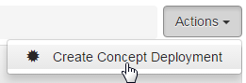1.

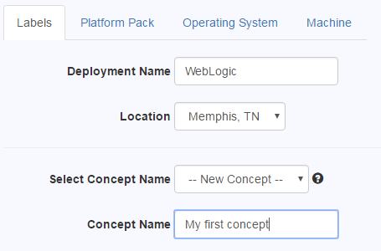2.

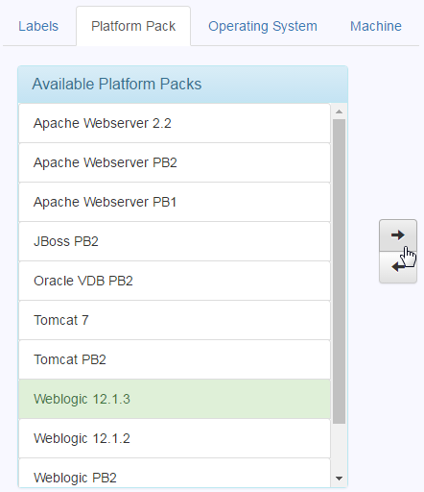3. Platform Pack and OS –

When you're done, click Continue to move to the Platform

Pack screen. On this screen, you can choose what type

of servers to create.

4. select what OS you'd like to use.

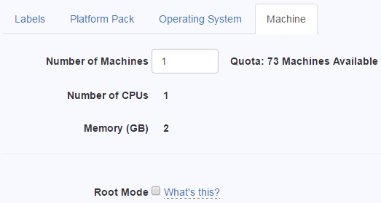5. you can choose how many VMs you want in this deployment. You can also choose whether you want to activate root mode

**Note**:

* Root mode - CloudOps sets up an application area on the servers for you to make it easy to start development. But if you need more control, you can get full control by activating root mode.
* If you're not certain that you need root mode, leave the box unchecked. You can always edit your concept later and enable it if you really need it.
* Root mode is irreversible - Once you activate root mode, it's permanent and can't be undone.

**Root mode** (Basically when people enable the root mode we don’t deal with that server anymore)

<http://docs.prod.cloud.fedex.com/sandbox/rootmode.html#you-39-re-your-own-sysadmin>

**| -- Making changes in the UI**

By enabling Root mode, you can changes your server however you like. So we disconnect your servers from our management infrastructure when you turn on root mode.

**| -- Password synchronization**

CloudOps stops synchronizing your server's password with your LDAP password.

**| -- Passwords for additional users**

If there are any user that are added before, by enabling the root mode they will lose the access password

**| -- Backups**

We don’t back it up. They have to do it their self.

**| -- You're your own sysadmin**

you're responsible for adding users, setting passwords, and any other maintenance on your system.

**Customize**

You can customize your deployment on these screens:

|  |  |
| --- | --- |
| **Platform** | -- Selection of platform pack, and selection of a particular release of your OS or platform pack. By default, the latest release is selected for you. |
| **Machines** | -- Number of machines and whether to activate root mode |
| **Software** | -- Optional software you can choose to install. Some software is only offered on certain platforms. |
| **OS Packages** | -- Additional operating system packages that are not part of the base OS installation. (Linux only.) |
| **Location** | -- Location where CloudOps will build your machines. You can only change this if you haven't yet built any machines for this deployment. |
| **Users** | -- Other people you'd like to share your server with. They will get the same level of access to the server that you have. Learn more about how users and directories work in the sandbox |

**Save and apply:**

When you're finished customizing your deployment, click the Save (to save your deployment's metadata) >> Action >> Apply Changes

**Expiration**

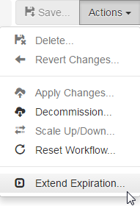Concepts you create in the sandbox are temporary.

They expire after 90 days, and you have the option to extend

each concept once for another 90 days.

You can extend your concept deployment's expiration one time by

90 days. To extend the expiration date, pull down the

**Actions >>** **Extend Expiration.**

If you haven't already used your extension,

you'll get another 90 days -- no approvals,

no questions asked, no waiting.

**Application User**

if the owner's FedEx ID is 12345, the application user's name would be fdx_12345.

**Directories**

directory in **/opt/fedex** - code, scripts, and other static files,

/var/fedex - data, logs, and other files that are created or modified at runtime.

These directories are named based on the application user's name.

* + /opt/fedex/fdx_12345
  + /var/fedex/fdx_12345

**Application Environments**

Place where you can host your enterprise application in environments that don't expire.

**Note**: Only people in the self-service program can create application deployments.

**Assign roles**

This controls who has access to the machines you create and how much access they have.

Available roles:

|  |  |
| --- | --- |
| **Developer**  **Host Access**  **Primary System**  **Administrator**  **Other System**  **Administrator** | People who can manage your application. They receive local Administrator access to your application's machines.  People who can log in to your application's machines, but have no extra permissions. They receive remote desktop access.  People responsible for managing the operating system on your application's machines. Your machines will be assigned to this group in asset tracking and inventory systems.  People who should have the same level of access to your machines as the primary system administrator team |

**To view Roles:**

Actions >> Manage Roles >>Windows/Linux

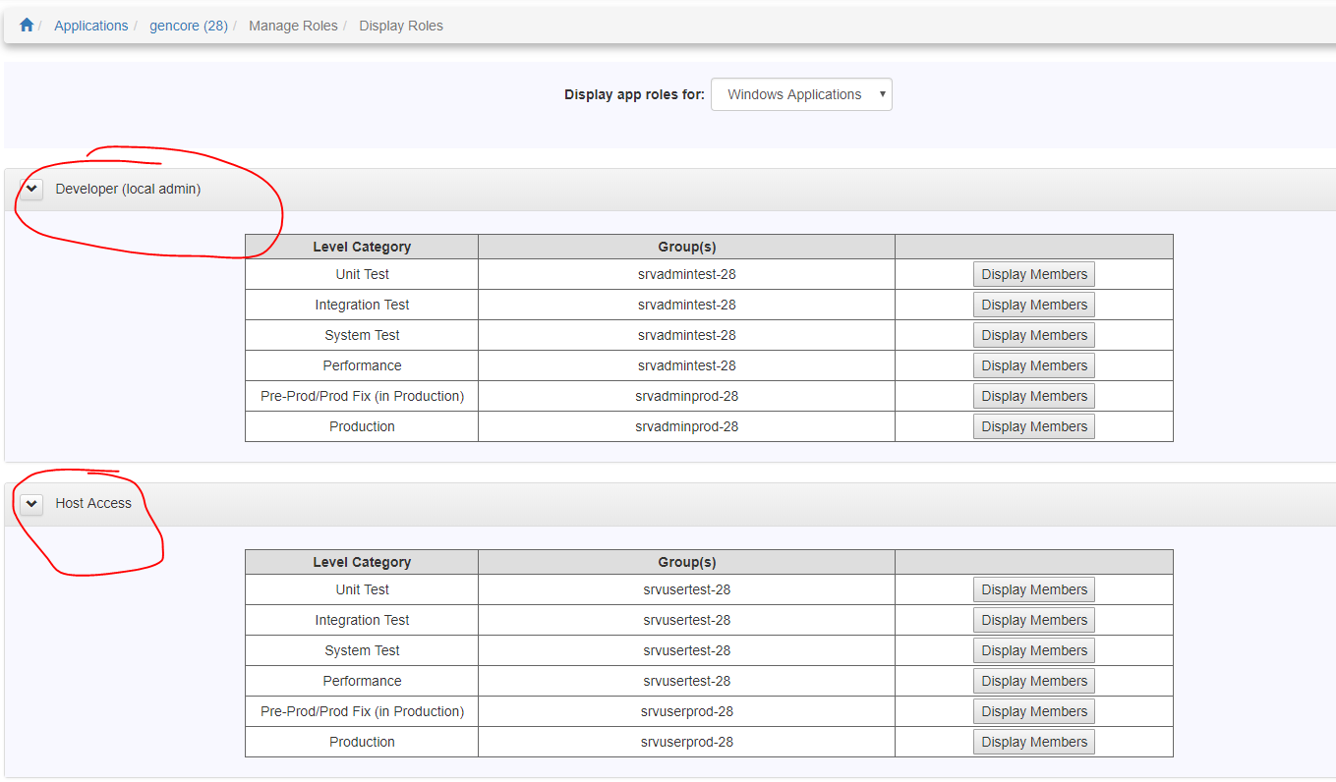

**CloudOps creates several Active Directory (AD) groups**, you **can't edit the role** assignments for the group. You can use the Display Members button to quickly see who is in the groups, You **can also request access** to one of the groups.

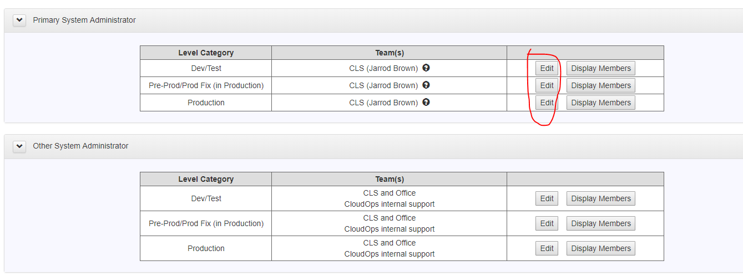

For the **System Administrator role**, you can choose from a predefined set of groups of system administrators. Click the **Edit** **button** and select the groups you want in **each level category.**

**Adding users to a role:**

**Home.fedex.com >> keyword "IMAGE" >> Manage User Access**

Search for users by the **FedEx ID** >> select as **many users** as you like >> **Select Access** button >> select the **role(s)** you'd like these users to have (application's name or EAI number) >> **Review & Submit button**, >> **Submit**

**Create a deployment**

**Actions** >> **Create App Deployment**

